Case Study – 8
Title / Aim :- A company wants to create an Online Job Application Form for applicants. The form should check the entered information immediately and prevent submission when the details are invalid.
Software/Tools Required :-
- Visual Studio Code (VS Code)
- Google Chrome / Any Web Browser
- HTML
- JavaScript

CODE:-
Index.html
<!DOCTYPE html>
<html lang="en">
<head>
<meta charset="UTF-8">
<meta name="viewport" content="width=device-width, initial-scale=1.0">
<title>TalentHub | Job Application</title>
<link rel="stylesheet" href="style.css">
</head>
<body>
<div class="app">
<!-- SIDEBAR -->
<aside class="sidebar">
<div class="brand">
<span>💼</span>
<div>
<h1>TalentHub</h1>
<small>CAREER PORTAL</small>
</div>
</div>
<div class="side-title">
APPLICATION
</div>
<nav>
<a class="active">
<span>01</span>
Personal Profile
</a>
<a>
<span>02</span>
Education
</a>
<a>
<span>03</span>
Career
</a>
<a>
<span>04</span>
Skills
</a>
</nav>
<div class="progress-box">
<p>Application Progress</p>
<div class="progress">
<div id="progressBar"></div>
</div>
<strong id="progressText">0%</strong>
</div>
<div class="sidebar-footer">
<span>🔒</span>
Your information is secure
</div>
</aside>
<main>
<div class="topbar">
<div>
<span class="welcome">WELCOME APPLICANT</span>
<h2>Join Our Team</h2>
</div>
<div class="portal-badge">
● Application Portal
</div>
</div>
<form id="jobForm">
<section class="form-section">
<div class="section-heading">
<div class="section-icon">👤</div>
<div>
<h3>Personal Profile</h3>
<p>Tell us about yourself</p>
</div>
</div>
<div class="field-grid">
<div class="field">
<label>Full Name *</label>
<input
type="text"
id="name"
placeholder="Enter your full name"
>
<small></small>
</div>
<div class="field">
<label>Date of Birth *</label>
<input type="date" id="dob">
<small></small>
</div>
<div class="field">
<label>Gender *</label>
<div class="gender-group">
<label>
<input type="radio" name="gender" value="Male">
Male
</label>
<label>
<input type="radio" name="gender" value="Female">
Female
</label>
<label>
<input type="radio" name="gender" value="Other">
Other
</label>
</div>
<small id="genderError"></small>
</div>
<div class="field">
<label>Email Address *</label>
<input
type="email"
id="email"
placeholder="name@example.com"
>
<small></small>
</div>
<div class="field">
<label>Mobile Number *</label>
<input
type="text"
id="mobile"
maxlength="10"
placeholder="10 digit mobile number"
>
<small></small>
</div>
<div class="field full">
<label>Address *</label>
<textarea
id="address"
placeholder="Enter your complete address"
></textarea>
<small></small>
</div>
<div class="field">
<label>City *</label>
<input type="text" id="city" placeholder="City">
</div>
<div class="field">
<label>State *</label>
<input type="text" id="state" placeholder="State">
</div>
<div class="field">
<label>PIN Code *</label>
<input
type="text"
id="pin"
maxlength="6"
placeholder="6 digit PIN"
>
</div>
</div>
</section>
<section class="form-section">
<div class="section-heading">
<div class="section-icon">🎓</div>
<div>
<h3>Academic Background</h3>
<p>Your educational qualification</p>
</div>

</div>
<div class="field-grid">
<div class="field">
<label>Highest Qualification *</label>
<select id="qualification">
<option value="">Select qualification</option>
<option>Diploma</option>
<option>Graduate</option>
<option>Post Graduate</option>
<option>PhD</option>

</select>
<small></small>
</div>
<div class="field">
<label>University / Institute *</label>
<input
type="text"
id="university"
placeholder="University / Institute"
>
<small></small>
</div>
<div class="field">
<label>Passing Year *</label>
<input
type="number"
id="passingYear"
placeholder="YYYY"
>
<small></small>
</div>
<div class="field">
<label>Percentage / CGPA *</label>
<input
type="text"
id="score"
placeholder="Example: 85% / 8.5 CGPA"
>
<small></small>
</div>
</div>
</section>
<section class="form-section">
<div class="section-heading">
<div class="section-icon">💼</div>
<div>
<h3>Career Profile</h3>
<p>Your professional experience</p>
</div>
</div>
<div class="field-grid">
<div class="field">
<label>Applying For *</label>
<select id="position">
<option value="">Select position</option>
<option>Software Developer</option>
<option>Web Developer</option>
<option>Data Analyst</option>
<option>Cyber Security Analyst</option>
<option>UI/UX Designer</option>
</select>
<small></small>
</div>
<div class="field">
<label>Total Work Experience *</label>
<select id="experience">
<option value="">Select experience</option>
<option>Fresher</option>
<option>0-1 Years</option>
<option>1-3 Years</option>
<option>3-5 Years</option>
<option>5+ Years</option>
</select>
<small></small>
</div>
<div class="field">
<label>Current / Previous Organization *</label>
<input
type="text"
id="organization"
placeholder="Company name"
>
<small></small>
</div>
<div class="field">
<label>Current Designation *</label>
<input
type="text"
id="designation"
placeholder="Your designation"
>
<small></small>
</div>
<div class="field">
<label>Expected Salary *</label>
<input
type="number"
id="salary"
placeholder="Annual salary"
>
<small></small>
</div>
</div>
</section>
<section class="form-section">
<div class="section-heading">
<div class="section-icon">💻</div>
<div>
<h3>Technical Skill Set</h3>
<p>Show us what you can do</p>
</div>
</div>
<div class="field-grid">
<div class="field full">
<label>Programming Languages *</label>
<input
type="text"
id="languages"
placeholder="Java, Python, JavaScript, C++..."
>
<small></small>
</div>
<div class="field full">
<label>Technical Skills *</label>
<textarea
id="skills"
placeholder="HTML, CSS, SQL, React, Git..."
></textarea>
<small></small>
</div>
<div class="field full">
<label>Certifications *</label>
<textarea
id="certifications"
placeholder="Enter your certifications"
></textarea>
<small></small>
</div>
</div>
</section>
<div class="submit-box">
<div>
<strong>Ready to apply?</strong>
<p>Check your details before submitting.</p>
</div>
<button type="submit">
SUBMIT APPLICATION →
</button>
</div>
<p id="result"></p>
</form>
</main>
</div>
<script src="script.js"></script>
</body>
</html>

Script.js
const form = document.getElementById("jobForm");
const result = document.getElementById("result");
const fields = {
name: {
element: document.getElementById("name"),
message: "Enter at least 3 characters",
validMessage: "Valid name",
validate: value => value.trim().length >= 3
},
dob: {
element: document.getElementById("dob"),
message: "Select your date of birth",
validMessage: "Date selected",
validate: value => value !== ""
},
email: {
element: document.getElementById("email"),
message: "Enter a valid email address",
validMessage: "Valid email",
validate: value =>
/^[^\s@]+@[^\s@]+\.[^\s@]+$/.test(value)
},
mobile: {
element: document.getElementById("mobile"),
message: "Enter a valid 10 digit number",
validMessage: "Valid mobile number",
validate: value =>
/^[0-9]{10}$/.test(value)
},
address: {
element: document.getElementById("address"),
message: "Enter your complete address",
validMessage: "Valid address",
validate: value => value.trim().length >= 10
},
city: {
element: document.getElementById("city"),
message: "Enter city",
validMessage: "Valid city",
validate: value => value.trim() !== ""
},
state: {
element: document.getElementById("state"),
message: "Enter state",
validMessage: "Valid state",
validate: value => value.trim() !== ""
},
pin: {
element: document.getElementById("pin"),
message: "Enter 6 digit PIN",
validMessage: "Valid PIN",
validate: value =>
/^[0-9]{6}$/.test(value)
},
qualification: {
element: document.getElementById("qualification"),
message: "Select qualification",
validMessage: "Qualification selected",
validate: value => value !== ""
},
university: {
element: document.getElementById("university"),
message: "Enter university / institute",
validMessage: "Institute entered",
validate: value => value.trim() !== ""
},
passingYear: {
element: document.getElementById("passingYear"),
message: "Enter a valid passing year",
validMessage: "Valid passing year",
validate: value => {
const year = Number(value);
return year >= 1950 && year <= new Date().getFullYear();
}
},
score: {
element: document.getElementById("score"),
message: "Enter percentage or CGPA",
validMessage: "Score entered",
validate: value => value.trim() !== ""
},
position: {
element: document.getElementById("position"),
message: "Select a job position",
validMessage: "Position selected",
validate: value => value !== ""
},
experience: {
element: document.getElementById("experience"),
message: "Select experience",
validMessage: "Experience selected",
validate: value => value !== ""
},
organization: {
element: document.getElementById("organization"),
message: "Enter organization name",
validMessage: "Organization entered",
validate: value => value.trim() !== ""
},
designation: {
element: document.getElementById("designation"),
message: "Enter designation",
validMessage: "Designation entered",
validate: value => value.trim() !== ""
},
salary: {
element: document.getElementById("salary"),
message: "Enter expected salary",
validMessage: "Salary entered",
validate: value => Number(value) > 0
},
languages: {
element: document.getElementById("languages"),
message: "Enter programming languages",
validMessage: "Languages entered",
validate: value => value.trim() !== ""
},
skills: {
element: document.getElementById("skills"),
message: "Enter technical skills",
validMessage: "Skills entered",
validate: value => value.trim() !== ""
},
certifications: {
element: document.getElementById("certifications"),
message: "Enter certifications",
validMessage: "Certifications entered",
validate: value => value.trim() !== ""
}
};
function validateField(field) {
const value = field.element.value;
const valid = field.validate(value);
const message = field.element
.parentElement
.querySelector("small");

field.element.classList.toggle("valid", valid);
field.element.classList.toggle("invalid", !valid);
if (message) {
message.textContent = valid
? "✓ " + field.validMessage
: "✕ " + field.message;
message.style.color = valid
? "#16A34A"
: "#DC2626";
}
updateProgress();
return valid;
}
Object.values(fields).forEach(field => {
field.element.addEventListener("input", () => {
validateField(field);
});
field.element.addEventListener("change", () => {
validateField(field);
});
});
function validateGender() {
const selected = document.querySelector(
'input[name="gender"]:checked'
);
const message = document.getElementById("genderError");
if (selected) {
message.textContent = "✓ Gender selected";
message.style.color = "#16A34A";
return true;
} else {
message.textContent = "✕ Select gender";
message.style.color = "#DC2626";
return false;
}
}
document.querySelectorAll(
'input[name="gender"]'
).forEach(radio => {
radio.addEventListener("change", () => {
validateGender();
updateProgress();
});
});
function updateProgress() {
const fieldCount = Object.keys(fields).length;
let completed = 0;
Object.values(fields).forEach(field => {
if (
field.validate(field.element.value)
) {
completed++;
}
});
if (validateGender()) {
completed++;
}
const total = fieldCount + 1;
const percentage = Math.round(
(completed / total) * 100
);
document.getElementById("progressBar").style.width =
percentage + "%";
document.getElementById("progressText").textContent =
percentage + "%";
}
form.addEventListener("submit", function(event) {
event.preventDefault();
let valid = true;
Object.values(fields).forEach(field => {
if (!validateField(field)) {
valid = false;
}
});
if (!validateGender()) {
valid = false;
}
if (valid) {
result.textContent =
"🎉 Application submitted successfully!";

result.style.color = "#16A34A";
window.scrollTo({
top: document.body.scrollHeight,
behavior: "smooth"
});
} else {
result.textContent =
"⚠️ Please correct the highlighted fields.";
result.style.color = "#DC2626";
}
});

Style.css
* {
box-sizing: border-box;
margin: 0;
padding: 0;
}
body {
font-family: Arial, sans-serif;
background: #F5F3FF;
color: #1E293B;
}

.app {
display: flex;
min-height: 100vh;
}
.sidebar {
width: 240px;
background: #111827;
color: white;
padding: 25px 18px;
position: fixed;
top: 0;
bottom: 0;
}
.brand {
display: flex;
align-items: center;
gap: 10px;
padding: 10px;
margin-bottom: 45px;
}
.brand > span {
font-size: 27px;
}
.brand h1 {
font-size: 20px;
}
.brand small {
color: #A78BFA;
font-size: 9px;
letter-spacing: 1px;
}
.side-title {
color: #94A3B8;
font-size: 11px;
margin: 0 10px 15px;
letter-spacing: 1px;
}
nav a {
display: flex;
align-items: center;
gap: 12px;
padding: 13px 12px;
margin-bottom: 7px;
border-radius: 8px;
color: #CBD5E1;
text-decoration: none;
font-size: 13px;
}
nav a span {
font-size: 11px;
color: #94A3B8;
}
nav a.active {
background: #7C3AED;
color: white;
}
nav a.active span {
color: white;
}
.progress-box {
background: #1E293B;
border-radius: 10px;
padding: 15px;
margin-top: 35px;
}
.progress-box p {
font-size: 12px;
color: #CBD5E1;
margin-bottom: 10px;
}
.progress {
height: 6px;
background: #334155;
border-radius: 10px;
overflow: hidden;
}
#progressBar {
width: 0%;
height: 100%;
background: #A78BFA;
transition: 0.3s;
}
#progressText {
display: block;
text-align: right;
margin-top: 7px;
color: #A78BFA;
font-size: 13px;
}
.sidebar-footer {
position: absolute;
bottom: 25px;
left: 25px;
right: 20px;
font-size: 11px;
color: #94A3B8;
}
main {
margin-left: 240px;
width: calc(100% - 240px);
padding: 35px 45px;
}
.topbar {
display: flex;
justify-content: space-between;
align-items: center;
margin-bottom: 30px;
}
.welcome {
font-size: 10px;
color: #7C3AED;
font-weight: bold;
letter-spacing: 1.5px;
}
.topbar h2 {
font-size: 28px;
margin-top: 5px;
color: #111827;
}
.portal-badge {
background: white;
padding: 10px 15px;
border-radius: 20px;
color: #16A34A;
font-size: 12px;
}
.form-section {
background: white;
border-radius: 14px;
margin-bottom: 22px;
padding: 25px 30px;
box-shadow: 0 3px 12px rgba(15, 23, 42, 0.06);
}
.section-heading {
display: flex;
align-items: center;
gap: 14px;
border-bottom: 1px solid #E2E8F0;
padding-bottom: 18px;
margin-bottom: 22px;
}
.section-icon {
width: 42px;
height: 42px;
background: #F3E8FF;
display: flex;
justify-content: center;
align-items: center;
border-radius: 10px;
font-size: 20px;
}
.section-heading h3 {
color: #111827;
font-size: 17px;
}
.section-heading p {
color: #64748B;
font-size: 12px;
margin-top: 4px;
}
.field-grid {
display: grid;
grid-template-columns: repeat(2, 1fr);
gap: 17px 20px;
}
.field.full {
grid-column: 1 / -1;
}
.field label {
display: block;
font-size: 12px;
font-weight: bold;
margin-bottom: 7px;
color: #334155;
}
.field input,
.field select,
.field textarea {
width: 100%;
border: 1px solid #CBD5E1;
border-radius: 7px;
padding: 11px;
font-size: 13px;
color: #1E293B;
background: #FFFFFF;
font-family: Arial, sans-serif;
}
.field textarea {
height: 75px;
resize: vertical;
}
.field input:focus,
.field select:focus,
.field textarea:focus {
outline: none;
border-color: #7C3AED;
box-shadow: 0 0 0 3px #F3E8FF;
}
.gender-group {
display: flex;
gap: 20px;
height: 38px;
align-items: center;
}
.gender-group label {
font-weight: normal;
margin: 0;
}
.gender-group input {
width: auto;
margin-right: 5px;
}
.field small,
#genderError {
display: block;
min-height: 15px;
margin-top: 4px;
font-size: 10px;
}
.valid {
border-color: #16A34A !important;
}
.invalid {
border-color: #DC2626 !important;
}
.submit-box {
background: #111827;
color: white;
border-radius: 12px;
padding: 22px 25px;
display: flex;
justify-content: space-between;
align-items: center;
}
.submit-box strong {
font-size: 15px;
}
.submit-box p {
color: #94A3B8;
font-size: 11px;
margin-top: 4px;
}
.submit-box button {
border: none;
background: #7C3AED;
color: white;
padding: 13px 22px;
border-radius: 7px;
cursor: pointer;
font-weight: bold;
font-size: 12px;
}
.submit-box button:hover {
background: #A78BFA;
}
#result {
text-align: center;
font-weight: bold;
margin: 18px 0;
}

Output
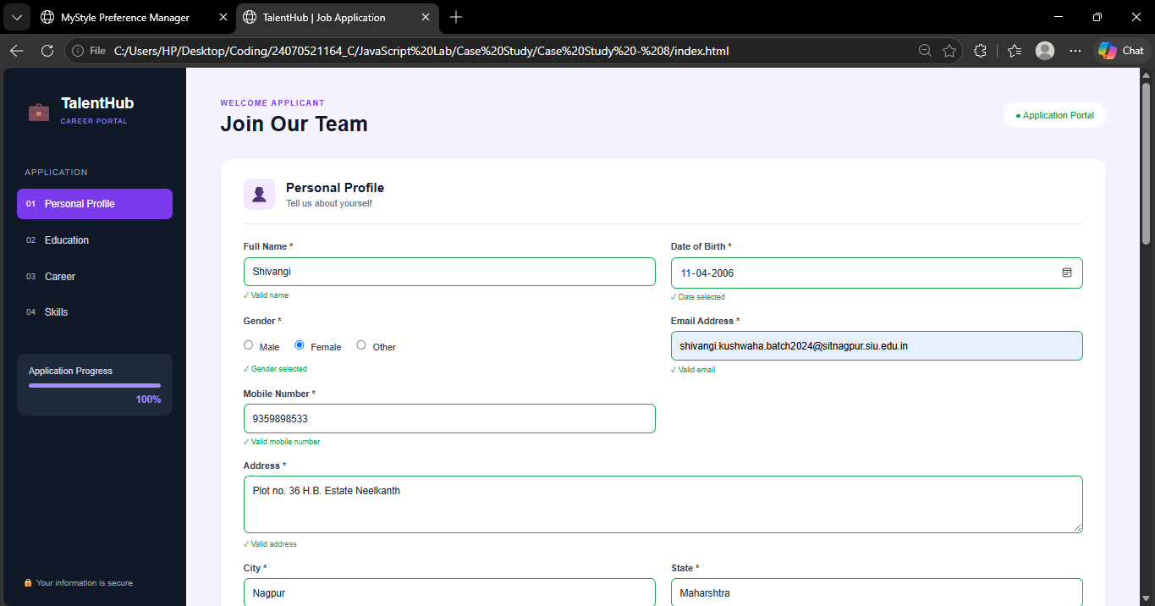
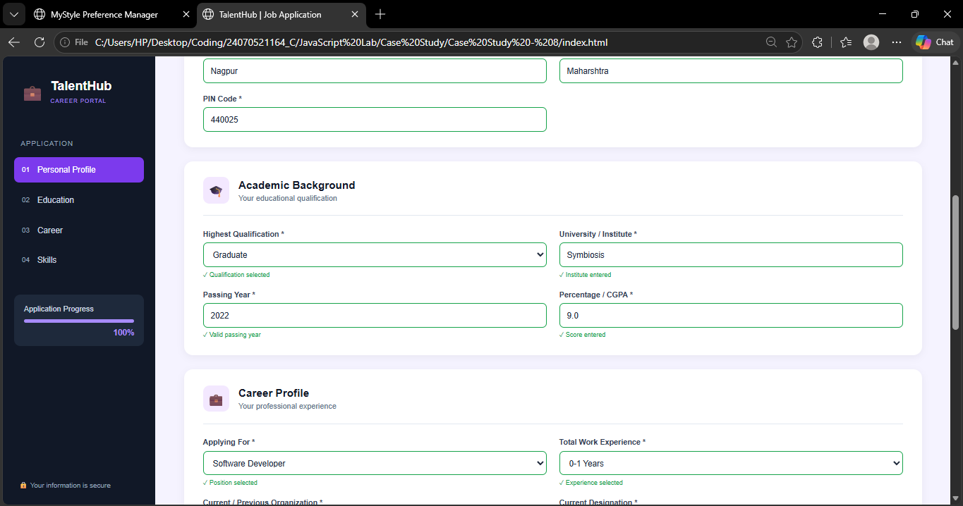

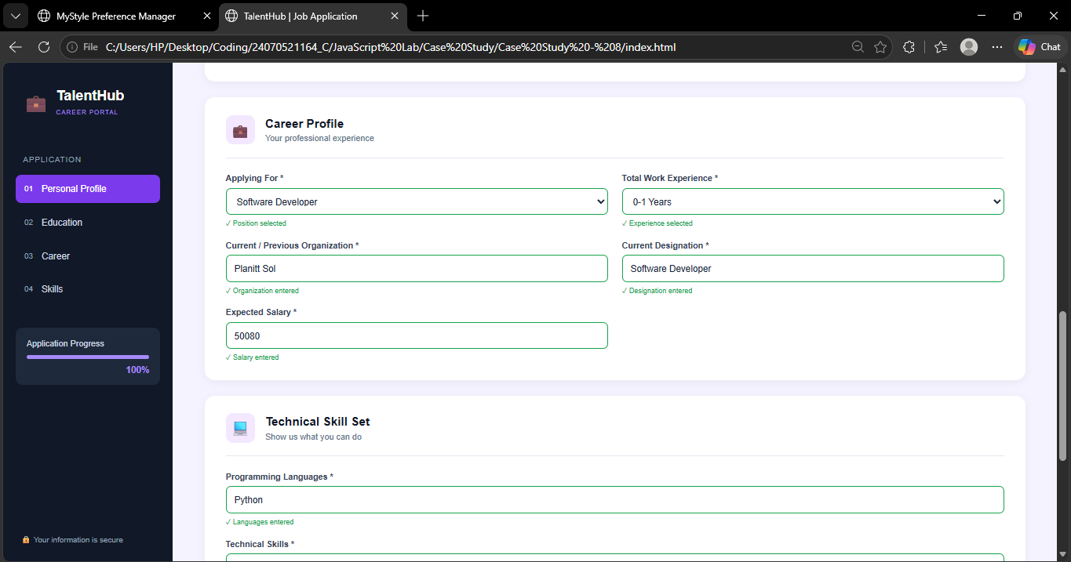

0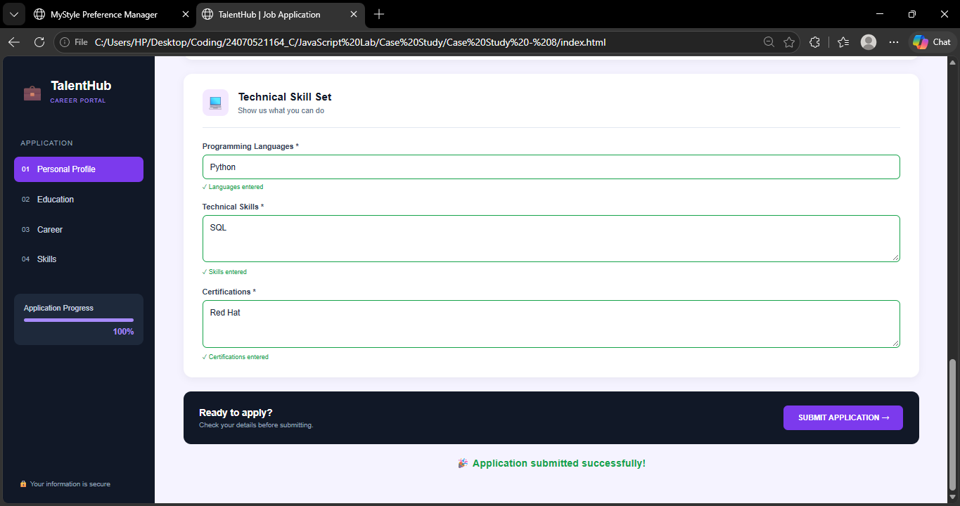

Result / Conclusion :-
The TalentHub Online Job Application Portal was successfully developed using HTML, CSS, and JavaScript. The application provides sections for personal information, educational qualifications, professional details, and technical skills. JavaScript performs real-time validation and displays appropriate success or error messages for invalid information. The submit event with preventDefault() prevents the form from being submitted when the entered details are invalid. Thus, the case study demonstrates practical implementation of DOM manipulation, event handling, form validation, Regular Expressions, and interactive web forms.

